

School of Computer Science, UPES, Dehradun.

Lab 8

DevSecOps Lab

B.TECH. - V Semester

**Submitted to:**

Dr. Hitesh Kumar Sharma

**Submitted by:**

Name: Ishika Mehrotra

Batch: Devops B1

Sap Id: 500124411

Roll No.: R2142230281

**Objective:** To set up Maven build job in Jenkins for automating the build process, enabling continuous integration to enhance the software development lifecycle

Step 1: Log in to Jenkins CI tool and configure Maven freestyle job

* 1. In the Jenkins dashboard, click on New Item

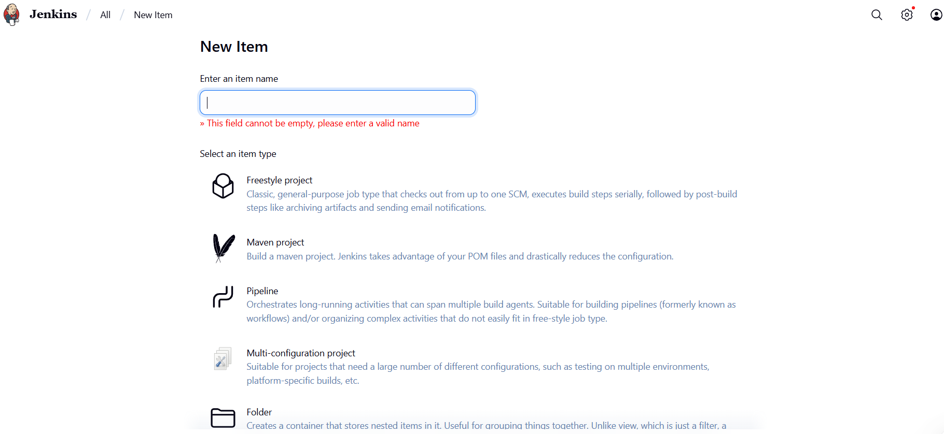

* 1. Select the Freestyle project while creating a Jenkins job, provide a custom job name, and click on OK

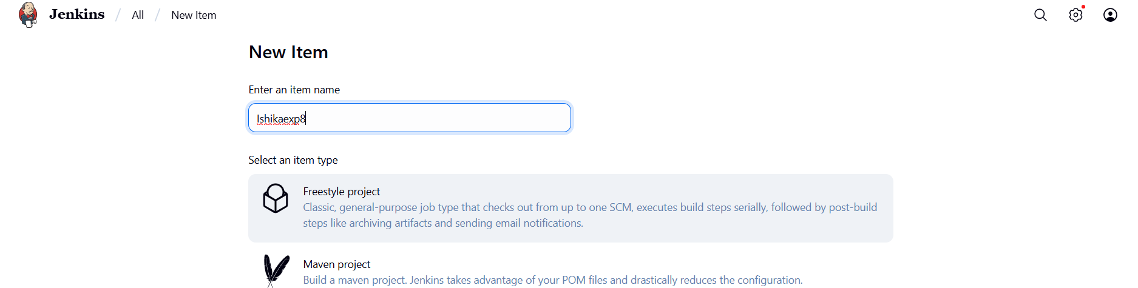

1.3 Now, in the Configure page, navigate to **Source Code Management** in the left navigation bar, select **Git**, and then provide the Git repository URL

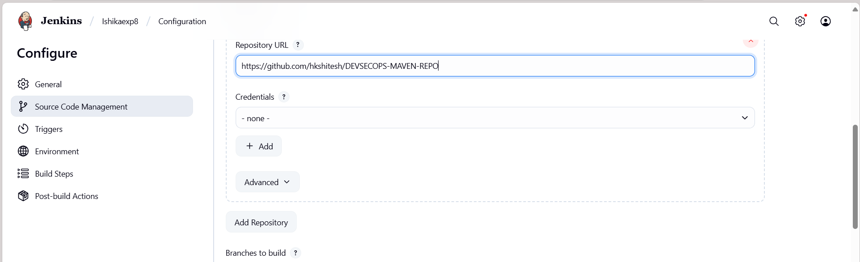

1.5 Now, navigate to **Build Steps**, click on **Add build step**, and then select the option **Invoke top-level Maven targets**

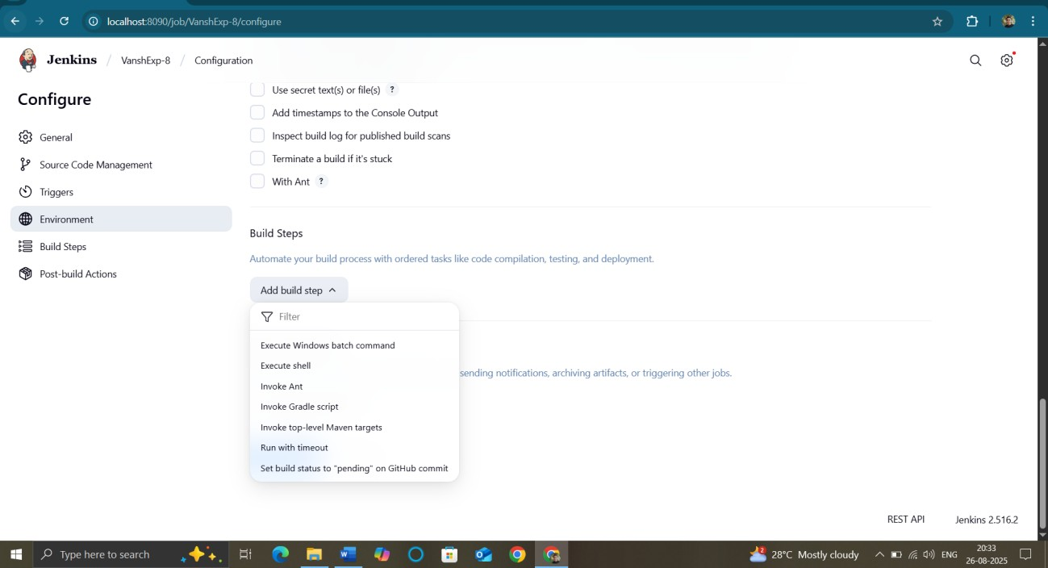

1.6 Provide clean install under **Goals** section and then click on **Save**

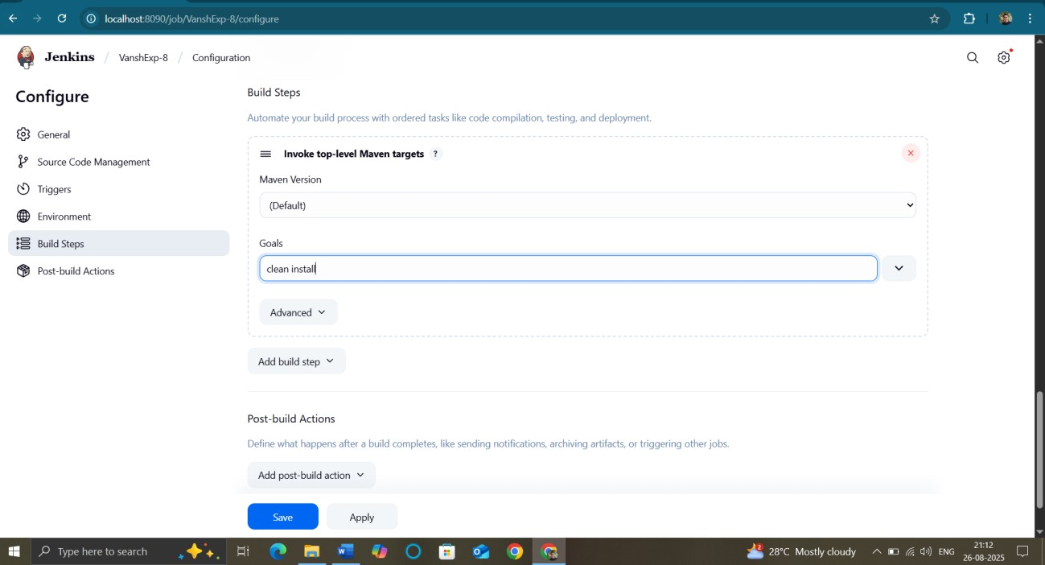

1.7 You will be navigated to the project after clicking on Save. Now, click on **Build Now** to initiate a new build, and the build logs will display the progress of the build process.

